

**“Antiviral Resistance and Bioweapons**

**– A Hypothesis”**

***BIOLOGY***

***PROJECT REPORT***

**UNDER THE GUIDANCE OF SUBMITTED BY:**

Ms. ESTHER REGINA V. SANJAY SHRINIVAAS

# BONAFIDE CERTIFICATE

*This is to certify that this project entitled “****Antiviral Resistance and Bioweapons – A Hypothesis****" is a record of bonafide work carried out by Master*  ***V. Sanjay Shrinivaas*** *in partial fulfilment of the requirements in* ***BIOLOGY*** *prescribed by* ***CBSE*** *for* ***AISSCE 2023-24*** *in* ***DELHI WORLD PUBLIC SCHOOL, Madurai.***

**DATE:12-10-2024**

_____________ _____________

**INTERNAL EXAMINER EXTERNAL EXAMINER**

____________________ __________ __________

### SENIOR SECONDARY COORDINATOR VICE PRINCIPAL PRINCIPAL

DECLARATION

*I hereby declare that the project work entitled "****Antiviral Resistance and Bioweapons – A Hypothesis****" submitted to* ***DELHI WORLD PUBLIC SCHOOL, Madurai*** *for* ***BIOLOGY*** *under the guidance of* ***MS. D. ESTHER REGINA PGT****, Biology facilitator is a record of original work done by us. We further declare that this project record or any part this has not been submitted elsewhere for any other purpose.*

***Place : Madurai***

***Date:12-10-2024***

# ACKNOWLEDGEMENT

*Apart from the efforts of me the success of any project depends largely on the encouragement and guidelines of many others. I take this opportunity to express my gratitude to the people who have been instrumental in the successful completion of this project.*

*I express a deep sense of gratitude to Almighty for giving me the strength for the successful completion of the project.*

*I express my heartfelt gratitude to my parents for constant encouragement while carrying out this project.*

*I gratefully acknowledge the contribution of the individuals who brought this project up to this level.*

*I express my deep sense of gratitude to our luminary Principal,*

***MS. SUNITHA DEVI and DWPS management*** *who have been continuously motivating and extending their helping hands to us.*

*I would like to express my heartfelt thanks to my biology facilitator,*

***Ms. ESTHER REGINA****, who has been instrumental to the success of this project and has been a constant support.*

*The guidance and support received from all the members who contributed and who are contributing to this project, was vital for the success of the project. I am grateful for their constant support and help.*

# TABLE OF CONTENTS

|  |  |  |
| --- | --- | --- |
| ***S.NO*** | ***DESCRIPTION*** | ***PAGE NO.*** |
| *i* | ***INTRODUCTION*** | 6 |
| *ii* | ***OBJECTIVES OF THE PROJECT*** | 7 |
| *iii* | **PREREQUISITE KNOWLEDGE** | 8 |
| *1* | **ANTIVIRAL RESISTANCE**  **OVERVIEW** | 9 |
| *2* | ***ANTIVIRAL RESISTANCE INTO A BIOWEAPON*** | 12 |
| *3* | ***CODE OF CONDUCT*** | 14 |
| *4* | ***ANTIVIRAL RESISTANCE IN SARS-COV-2*** | 15 |
| *5* | ***WEAPONIZED SARS-COV-2*** | 17 |
| *6* | ***ANTIVIRAL RESISTANCE IN RABIES VIRUS*** | 21 |
| *7* | ***WEAPONIZED RABIES VIRUS*** | 23 |
| *8* | ***CONCLUSION*** | 27 |
| *9* | ***BIBLIOGRAPHY*** | 30 |
| *10* |  |  |

*#Introduction*

In this part of research, we will be dealing with what actually is the content in this research paper about…

***Antiviral resistance*** is emerging as a significant concern that could complicate future pandemic responses.

“ *Antiviral resistance refers to the ability of viruses to withstand the effects of antiviral medications designed to inhibit their replication.*”

This resistance can evolve rapidly due to genetic mutations and selective pressures, making previously treatable infections increasingly dangerous. In addition to public health implications, the potential ***weaponization*** of *resistant pathogens* raises serious ethical and security concerns.

*This paper investigates* specific *bacterial* and *viral* strains that could potentially be manipulated for use as bioweapons, alongside the broader consequences of antiviral resistance on global health.

*#Objective*

The main objective of this paper is to find out how the potentially harmful germs can be manipulated in to terrible killers…

**The primary objectives of this research are:**

* To analyze the mechanisms by which bacteria and viruses develop *resistance to antiviral and antibiotic treatments.*
* To examine *specific strains* of bacteria and viruses that could *potentially* be manipulated for use as bioweapons.
* To assess the *real-world consequences* of antimicrobial resistance, including the potential for pandemics and the implications for public health systems.

*#Prerequisite Knowledge*

**Before we get into research, we have some key terms to know about:**

1. **Antimicrobial Resistance:**

A condition seen in microbes where they no longer respond to any drugs are medicines given to the patient in order to kill that microbe.

1. **Antiviral Resistance:**

Antiviral resistance occurs when a virus stops responding to an antiviral medication. The virus changes, making an antiviral drug less effective or completely ineffective. A virus that develops antiviral resistance is harder to treat.

1. **Bioweapon:**

A biological weapon, also known as a bioweapon, is a microorganism or toxin that is intentionally released to kill or harm humans, animals, or plants. Biological weapons can be deadly and highly contagious, and can spread rapidly around the world.

*|1| Antiviral Resistance Overview*

Antiviral resistance occurs when a virus stops responding to an antiviral medication. The virus changes, making an antiviral drug less effective or completely ineffective. A virus that develops antiviral resistance is harder to treat.Antiviral resistance is a type of antimicrobial resistance.

***1.1)Cause:***

1. Antivirals help lower the amount of a virus (viral load), but the virus is always there. If you miss prescribed doses of an antiviral or stop treatment too soon, the virus may start multiplying again. As it replicates, *the virus’s genetic makeup may mutate* (change).
2. If a virus goes through too many changes, the antiviral drug won’t recognize the new virus variant (version of the virus). *Once a virus is drug resistant, the medication can’t keep it from multiplying*.
3. Sometimes, a virus stops responding to previously effective antivirals for no known reason. This effect is called *spontaneous resistance*.

* These results in a very dangerous condition. Imagine that the antiviral drug or vaccine which is currently put to use is of no use when SARS-CoV-2 a virus which is the main reason behind the *Novel Coronavirus Pandemic* gains antiviral resistance.

***1.2)Scenario 1:***

*1.2.1)SARS-CoV-2 gains antiviral resistance:*

1)If ***SARS-CoV-2*** were to develop *antiviral resistance* *due to the discontinued use of certain antiviral treatments* or vaccines, the consequences could be **severe**. Antiviral resistance could emerge when the virus mutates, particularly in immunocompromised individuals who are unable to clear the virus quickly. These individuals might receive prolonged treatment with antiviral drugs, leading to the development of resistant variants.

2)As observed in **recent studies**, ***SARS-CoV-2*** variants *resistant* to *antivirals like Paxlovid and remdesivir* have already emerged in such patients. These resistant strains can still replicate and spread effectively, posing a significant risk to the general population.

3)A scenario where resistance spreads could lead to new waves of infections with *reduced treatment efficacy.* The percentage likelihood of such resistance becoming widespread depends on multiple factors, including the frequency of immunocompromised patients harboring the virus, the rate of transmission of resistant variants, and the global response in terms of developing new treatments or vaccines.

*1.2.2)Scenario status :*

* ***Percent Chance for the scenario to occur:*** *30%-40%.*
* ***Why****: Mutations in immunocompromised individuals after prolonged antiviral exposure.*
* ***How****: Resistant strains emerge due to viral evolution during extended infections.*
* ***Chances of human extinction****: Extremely low, near 1%.*
* ***Measure****: Closely monitoring immunocompromised patients and adjusting treatment strategies.*

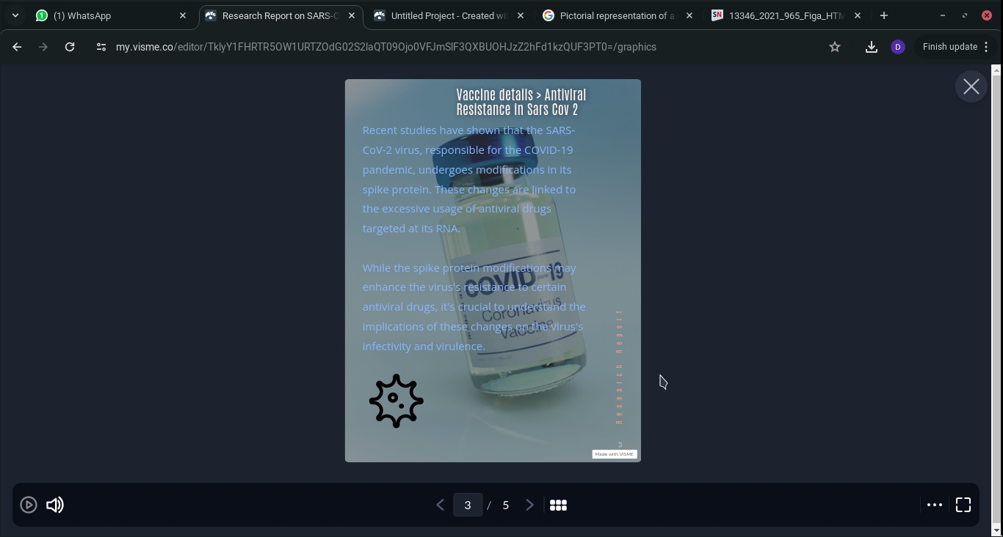

*|2|Antiviral Resistance into a Bioweapon*

***2.1) Bioweapon:***

A bioweapon (biological weapon) is a biological agent—such as bacteria, viruses, fungi, or other microorganisms—or toxins derived from living organisms that are deliberately used to cause disease or death in humans, animals, or plants.

**Most importantly any antiviral resistive virus can be easily upgraded into a Bioweapon due to it's resistive ability towards existing antiviral vaccines and high chances of mutation.**

*2.1.1) Characteristics of a Bioweapon*

1. **Ease of Transmission**: Many bioweapons are designed or selected for their ability to spread quickly, often through air, water, or direct contact.
2. **High Mortality or Morbidity**: The biological agents used can cause widespread illness, suffering, or death, with long-lasting impacts on populations.
3. **Difficult Detection**: Some bioweapons may have delayed effects, making them hard to detect until symptoms appear, which complicates the response and containment.

*2.1.2) Types of Bioweapon*

1. **Bacteria**: Examples include *Bacillus anthracis* (which causes *anthrax*) and *Yersinia pestis* (which causes *plague*). These can be resistant to antibiotics and spread rapidly.
2. **Viruses**: Examples include the *smallpox virus* and weaponized strains of viral hemorrhagic fevers, like *Ebola*. Viruses can mutate rapidly, increasing their resistance to vaccines or antiviral drugs.

*2.1.3) Mechanism of action*

Bioweapons can enter the body through inhalation, ingestion, or skin contact. Once inside the body, the agents disrupt normal biological processes, often leading to infection, immune system collapse, or death. Because of the rapid spread and high lethality, bioweapons can quickly devastate entire populations.

*2.1.4)Bioweapons in History*

* **Anthrax Attacks in 2001**: Letters containing anthrax spores were mailed to U.S. media outlets and government offices, causing several deaths and widespread fear.
* **Japanese Biological Warfare (Water Purification Unit 731)-**: During World War II, Japan’s Unit 731 conducted biological warfare experiments in China, using pathogens like *plague*, *cholera*, and *anthrax* to infect civilians.

*|3|Code of Conduct*

* **The bacterial strain**, for instance, is one that has developed extreme resistance to all known antibiotics. This type of *antibiotic-resistant* bacteria could cause infections that are nearly impossible to treat, leading to high mortality rates and uncontrollable outbreaks. The mechanisms of this resistance, the role of overuse and misuse of antibiotics, and the public health impact of such bacterial threats will be explored.
* **On the viral side**, a novel strain of a rabies-like virus will be considered, one that not only develops resistance to antiviral treatments but also mutates rapidly, making it highly transmissible. The virus could induce aggressive, cannibalistic behavior in its hosts, spreading through bites and escalating rapidly into a pandemic. The nature of viral mutations, treatment challenges, and the alarming consequences of such viral threats will be thoroughly analyzed.
* Examination of how some of the most potential and most common, harmful virus strains can be manipulated into a antiviral resistant strain, and further be upgraded into a Bioweapon, as the advancements in biological and technology and gene editing is ever ending, further poses existential threats…

*|4|Antiviral Resistance in SARS-CoV-2*

***4.1) Introduction***

*SARS-CoV-2*, the virus responsible for COVID-19, has shown a high capacity for *mutation* and *adaptation*, posing significant challenges for global healthcare systems. As a rapidly evolving virus, its ability to develop resistance to antiviral drugs presents a dangerous potential for manipulation in bioweapons development. In biosafety level 4 (BSL-4) labs, where the most dangerous pathogens are studied, the manipulation of *SARS-CoV-2* could result in the creation of a highly contagious and aggressive bioweapon.

***4.2) Taxonomical Details***

1. **Domain**: *Viruses*
2. **Order**: *Nidovirales*
3. **Family**: *Coronaviridae*
4. **Genus**: *Betacoronavirus*
5. **Species**: *Severe acute respiratory syndrome-related coronavirus (SARS-CoV-2)*

***4.3) Current Status***

*SARS-CoV-2* has caused a global pandemic, with over 250 million confirmed cases and more than 5 million deaths worldwide. While vaccines and antiviral treatments such as Remdesivir and Molnupiravir have been developed, the virus’s rapid mutation has led to the emergence of new variants, such as *Delta* and *Omicron*, some of which show partial resistance to these treatments. The virus’s ability to mutate in the spike protein has allowed it to evade neutralizing antibodies, reducing the efficacy of vaccines and antiviral drugs.

***4.4) Drugs Currently Used to Control SARS-CoV-2***

**Remdesivir**: A nucleotide analog that inhibits viral RNA polymerase.

**Molnupiravir**: Causes lethal mutagenesis of the virus during replication.

**Paxlovid**: A protease inhibitor that prevents viral replication.

**Monoclonal Antibodies**: Used to block the virus from attaching to human cells.

Despite these treatments, SARS-CoV-2 continues to evolve, raising concerns about the virus becoming increasingly resistant to antivirals.

***4.5) Mutation Phase and Antiviral Resistance***

SARS-CoV-2 has demonstrated a high mutation rate, particularly in its spike protein, which is responsible for binding to the ACE2 receptors on human cells. This could happen through:

1. **Selective Pressure:** Prolonged exposure to antiviral drugs in immunocompromised patients could drive mutations that help the virus survive despite treatment.
2. **Error-Prone Replication:** The virus’s RNA-dependent RNA polymerase lacks proofreading capability, leading to frequent errors during replication, which could accumulate to create a drug-resistant strain.

*|5|Weaponized SARS-Cov-2*

* With such ability of antiviral resistance, the SARS-Cov-2 can be further upgraded into a Bioweapon by some illicit groups or a group of terrorists to rise destruction in targeted countries.

***5.1)Potential Mutations in SARS-Cov-2:***

*SARS-CoV-2* has a high mutation rate due to the lack of proofreading mechanisms in its RNA replication process. These mutations often occur in the spike protein, which enables the virus to bind to the ACE2 receptors on human cells. Variants that have emerged demonstrate how quickly *SARS-CoV-2* can adapt, including:

1. **N501Y mutation**: Increases affinity for ACE2, making the virus more transmissible.
2. **E484K mutation**: Contributes to immune escape, allowing the virus to evade neutralizing antibodies.
3. **D614G mutation**: Found to enhance the infectivity of the virus.

* If mutations occur in areas targeted by antiviral drugs, especially protease inhibitors or polymerase inhibitors, *SARS-CoV-2* could render most current treatments ineffective. Under such a scenario, the virus would become an uncontrollable threat.

***5.2) Bioweapon Potential: How SARS-CoV-2 Could Be Engineered***

If manipulated in a BSL-4 lab, SARS-CoV-2 could be transformed into a bioweapon by leveraging its mutagenic potential and drug resistance. Key areas for manipulation include:

1. **Increased Transmission Rate:**

By modifying the spike protein to bind more effectively to human receptors, the virus could become far more contagious. Aerosol transmission could be enhanced, making it easier to spread in enclosed spaces or over longer distances.

1. **Enhanced Symptom Severity:**

Genetic modifications could make the virus trigger more severe immune responses, such as cytokine storms, resulting in increased mortality rates. This could be achieved by altering viral proteins that interact with the human immune system, leading to hyperactivation of inflammatory pathways.

1. **Increased Resistance to Antivirals:**

Through engineered mutations, the virus could develop resistance not only to current drugs but also to any new treatments developed in response. This could involve introducing mutations that prevent antiviral drugs from binding to viral proteins, such as protease or polymerase enzymes.

1. **Combining with Other Pathogens:**

A terrifying possibility is combining *SARS-CoV-2* with other lethal pathogens, such as *Ebola* or *Marburg viruses*. The result could be a virus with the high transmission rate of *SARS-CoV-2* and the lethality of hemorrhagic fevers. Alternatively, the virus could be engineered to carry genes from highly resistant bacteria, creating dual infection scenarios that overwhelm the immune system.

1. **Increased Incubation Period:**

To make detection and containment more difficult, SARS-CoV-2 could be engineered with a longer incubation period. Infected individuals would remain asymptomatic for extended periods, unknowingly spreading the virus across communities and borders.

1. **Cannibalistic Behavior and Neuropsychological Impact:**

Through gene manipulation, particularly of neuroinvasive properties, SARS-CoV-2 could be engineered to induce neurological damage that leads to aggressive behavior. This could involve hijacking neural pathways that control aggression, resulting in victims exhibiting violent, uncontrollable behaviors—potentially biting or attacking others. The Rabies virus, which affects brain regions controlling aggression, could serve as a model for such neuroinvasive mutations.

***5.3) Transmission and Fatality Rate in a Bioweapon Scenario***

In its current form, SARS-CoV-2 has a case fatality rate of around 1-2% globally, though this varies depending on healthcare infrastructure. If upgraded into a bioweapon, the fatality rate could skyrocket, especially if combined with other pathogens or made more aggressive.

The virus’s transmission rate, which currently ranges from 2-3 individuals per infected person (basic reproduction number R0), could be boosted to significantly higher levels with genetic modifications. This could be done by enhancing its ability to survive in aerosols or on surfaces for longer periods.

***5.4) Overuse of Antiviral Drugs Leading to Resistance***

The overprescription of antiviral drugs, particularly in regions with high COVID-19 infection rates, could accelerate the development of resistant strains. Just as bacteria become resistant to antibiotics through misuse, SARS-CoV-2 could gain resistance to antiviral treatments. This could happen via:

1. **Mutation Under Selective Pressure:** As antiviral drugs are used, they create a selective environment where only resistant strains survive and propagate.
2. **Incomplete Treatment Courses:** Patients not completing prescribed treatment could allow partially resistant strains to proliferate.
3. **Use in Immunocompromised Patients:** Prolonged viral replication in immunocompromised individuals provides ample opportunity for resistant mutations to arise.

* If this resistance is then ***exploited in the lab***, a resistant strain could be weaponized to ensure that no existing antiviral drugs are effective against it, increasing the lethality and making it nearly impossible to control.

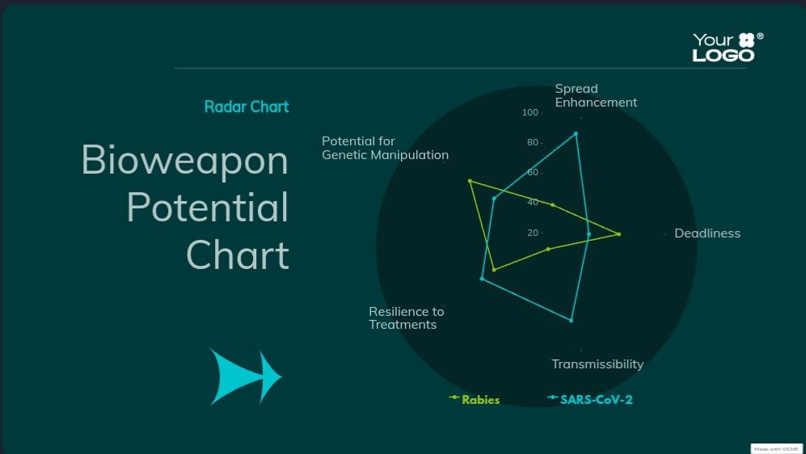

***Fig 5,7.1 > Bioweapon potential of viruses with antiviral resistance.***

*|6|Antiviral Resistance in Rabies Virus*

***6.1) Introduction***

*Rabies* is a viral infection caused by the Rabies virus from the *Lyssavirus genus* within the *Rhabdoviridae* family. Known for its nearly 100% fatality rate once symptoms begin, rabies has been historically controlled through vaccines and post-exposure prophylaxis (PEP). However, the potential for antiviral resistance in rabies raises significant concerns for global public health. Rabies is an RNA virus with a single-stranded, negative-sense genome. It is known for its neurotropic behavior, meaning it primarily targets the nervous system, ultimately causing encephalitis, or inflammation of the brain, which results in the hallmark symptoms of the disease: aggression, confusion, hallucinations, and hydrophobia (fear of water).

***6.2) Taxonomical Details***

1. **Domain:** *Virus*
2. **Order:** *Mononegavirales*
3. **Family:** *Rhabdoviridae*
4. **Genus:** *Lyssavirus*
5. **Species:** *Rabies virus*

***6.3) Current Status***

Rabies typically spreads through animal reservoirs, with dogs being the most common carriers in developing countries, while bats and other wildlife serve as carriers in developed regions. The incubation period for rabies can range from weeks to several months, making early diagnosis difficult and limiting the effectiveness of pre-symptomatic treatments.

***6.4) Drugs currently used to treat Rabies***

Currently, there is *no cure for rabies* once symptoms appear. Treatment focuses on prevention through post-exposure prophylaxis (PEP) and vaccination. Key interventions include:

1. **Post-Exposure Prophylaxis (PEP):** A combination of rabies immunoglobulin (RIG) and the rabies vaccine administered immediately after exposure to the virus.
2. **Vaccination:** Both pre-exposure and post-exposure vaccines are available. Pre-exposure vaccination is given to individuals at high risk (e.g., veterinarians, travelers to endemic regions), while post-exposure vaccination is provided to anyone who may have been exposed to the virus.

***6.5) Mutation Phase and Antiviral Resistance***

* Viruses, especially RNA viruses like rabies, mutate rapidly due to their lack of proofreading mechanisms during replication. Although rabies itself has not yet shown significant antiviral resistance, the potential for a rabies-like virus to evolve resistance to current treatments, such as antiviral chemicals or vaccines, is concerning.
* The overuse of antiviral injections and immune-based treatments could drive selective pressure, allowing resistant strains to survive. In addition, incomplete or improper treatment courses, as well as misuse of vaccines, could contribute to the emergence of resistant strains.

*|7|Weaponized Rabies Virus*

***7.1) Potential Mutations***

A well-known example of a rabies virus strain with potential for higher virulence is rabies virus variant 3027, which has been documented in certain bat species. This strain shows increased neurotropism (affinity for nervous tissue) and replicates more aggressively in the central nervous system, leading to a faster progression of symptoms compared to other strains.

While this strain is not yet resistant to antiviral treatments, its enhanced ability to spread within the nervous system poses a potential risk for mutations that could lead to immune evasion or antiviral resistance. Further manipulation of this strain, for example, through laboratory engineering to increase its ability to bypass the immune response, could potentially turn it into a highly dangerous bioweapon with increased fatality rates and rapid transmission.

This highlights the importance of monitoring rabies strains circulating in wildlife and ensuring stringent biosecurity in labs that handle such pathogens.

***7.2) Bioweapon Potential : How Rabies virus can be upgraded into a bioweapon.***

1. **Genetic Manipulation for Resistance:**

* **Alteration of Glycoproteins:** The rabies virus uses its glycoprotein to enter human cells. Current vaccines target this glycoprotein to neutralize the virus. By manipulating the glycoprotein structure, scientists could create a strain that avoids detection by the immune system and is resistant to vaccines and PEP.
* **Increased Mutation Rates:** The viral RNA could be engineered to mutate even faster, allowing it to adapt more quickly to antiviral environments, leading to the evolution of strains resistant to multiple lines of treatment.

1. **Enhancing Transmission:**

* **Bite Transmission and Cannibalistic Behavior:** Rabies spreads through bites from infected animals. A bioweaponized version could be designed to enhance aggressive behavior in humans and animals, causing increased rates of biting and, thus, faster transmission. This strain could induce a form of hyper-aggression or even cannibalistic tendencies, leading to widespread, chaotic outbreaks.
* **Airborne or Environmental Stability:** While rabies is not typically spread through respiratory droplets, an engineered version could gain this ability, drastically increasing the rate of transmission and making containment efforts far more difficult.

1. **Combination with Other Pathogens:**

* **Hybridization with Other Viruses:** Genetic engineering could lead to the hybridization of rabies with other pathogens, such as the influenza virus, to create a “supervirus.” This hybrid virus could combine the high fatality rate of rabies with the rapid airborne transmission of influenza, resulting in a catastrophic pandemic.
* **Increased Incubation Periods:** A longer asymptomatic period could be engineered into the virus, allowing it to spread undetected before symptoms appear, increasing the global reach of the outbreak.

***7.3) Transmission and Fatality rate in a bioweapon scenario.***

1. **Fatality Rate:** The rabies virus already has a 100% fatality rate once clinical symptoms develop. If antiviral resistance is developed, and no effective treatment or prevention exists, the fatality rate would remain near total for those infected.
2. **Rapid and Uncontrolled Spread:**

* **Increased Transmission:** A bioweaponized rabies strain with airborne transmission capabilities or enhanced bite transmission would cause the virus to spread far more rapidly than the natural version.
* **Global Outbreaks:** The longer incubation period, combined with hyper-aggressive behavior, would lead to a delay in detecting the outbreak, making containment incredibly difficult. This would result in large-scale infections across multiple countries, leading to a pandemic scenario.

1. **Human and Economic Costs:**

* **High Mortality:** With no available treatment, infection rates could spiral out of control, with mortality reaching millions, especially in densely populated or poorly vaccinated regions.
* **Economic Collapse:** As infected individuals spread the virus rapidly and unpredictably, healthcare systems would become overwhelmed, causing economic strain, panic, and breakdowns in societal structure. Entire nations could face collapse due to the chaos of uncontrolled outbreaks.

***7.4) Overuse of antiviral drugs leading to resistance.***

For rabies, key proteins like the glycoprotein (G-protein) and polymerase (L-protein) are essential for viral replication and immune evasion. Mutations in these proteins could lead to forms of rabies that evade immune responses or survive despite antiviral interventions.[Below given is an image of rabies virus (red) invading a neuron.

**Potential for Resistance Development**

1. **Mutation in G-Protein:** If the G-protein, which allows the rabies virus to attach to host cells, mutates in a way that prevents antiviral drugs from blocking it, the virus could become resistant. This could make the virus more effective at invading host cells, and thus, harder to treat with current antivirals.
2. **Mutation in L-Protein:** The L-protein is essential for viral replication. Mutations in the active site of this enzyme could prevent antivirals from inhibiting viral replication, making treatments ineffective. Resistant strains would then have a survival advantage, leading to an increased prevalence of resistant rabies viruses.

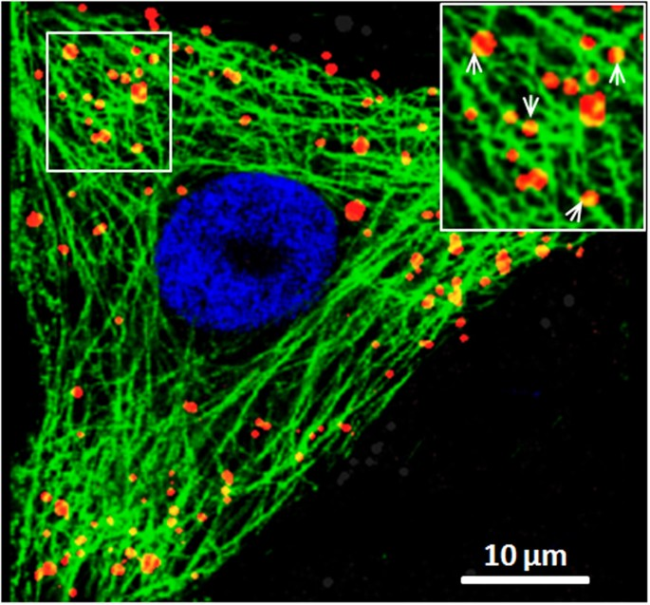*|8|Conclusion*

* By using biological tools and with the help of artificial intelligence, we can create an assumption to an average of how the 2 viruses can gain antiviral resistance in the far future.

***8.1)Graph***

This graph shows us the possibilities of how the virus could evolve to gain antiviral resistance.

**Y-Axis:** Antiviral Resistance in %

**X-Axis:** Timeline in Years

***Fig 8.1 > Line graph of a viruses gaining antiviral resistance.***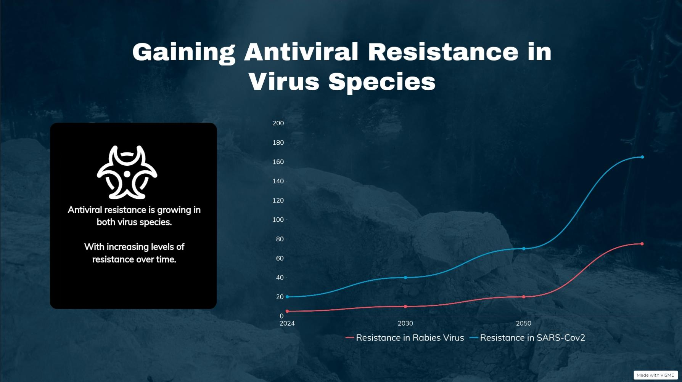

***8.2) Possibility of Rabies Being used as a bioweapon in 2050***

* Rabies is already a deadly virus, but its natural mode of transmission (through bites) limits its large-scale spread. However, in a future scenario, manipulation to increase its transmissibility or resistance could change that.
* By **2050**, advancements in synthetic biology or gene-editing technologies like *CRISPR* could allow the virus to be modified for targeted attacks, especially if combined with another virus or pathogen.
* By **2050**, the *convergence of advanced gene-editing tools*, antiviral resistance, and the potential for enhanced transmission could make rabies one of the most dangerous bioweapons if not controlled properly.

***8.3) Possibility of SARS-Cov2 Being used as a bioweapon in 2050***

* ***Advances in Synthetic Biology***: By 2050, advances in synthetic biology and gene-editing tools such as CRISPR will make it easier to manipulate viruses like SARS-CoV-2. A bioweaponized strain could be tailored to evade immune responses, spread more efficiently, or be resistant to all known treatments.
* ***Dual-Use Research:*** Some of the research on coronaviruses may have dual-use potential, meaning that research intended for defensive or preventive purposes could be repurposed for offensive bioweapon use. The ease of manipulating viruses in labs increases the risk of such applications.
* ***Targeted Attacks:*** Weaponizing SARS-CoV-2 for targeted bioweapon attacks could be done by releasing the virus in specific locations with high population densities. If a resistant strain were created, it could spread uncontrollably through both urban centers and rural areas, with devastating effects.
* SARS-CoV-2, while already a virus with significant global impact, has the potential to be modified into a bioweapon by 2050. The rise of antiviral resistance, combined with advances in genetic engineering, creates the potential for the virus to be manipulated into a form that is more transmissible, lethal, and resistant to treatments, making it one of the most dangerous bioweapon candidates of the future. Preventive measures, including better regulation of research and the development of next-generation treatments, will be crucial to mitigate this risk.

*|E|Bibliography*

1. *World Health Organization. (2021).* Antimicrobial resistance: Key facts. Retrieved from WHO website
2. *Centers for Disease Control and Prevention. (2020).* Antibiotic Resistance Threats in the United States. Retrieved from CDC website
3. Laxminarayan, R., et al. (2013). Antibiotic resistance—the need for global solutions. *The Lancet Infectious Diseases, 13(12), 1057-1098.*
4. O’Neill, J. (2016). *Tackling drug-resistant infections globally:* Final report and recommendations. Wellcome Trust and HM Government
5. Mofid, M. M., & Arora, R. (2019). *Antimicrobial resistance and the role of infectious disease physicians.* American Journal of Medicine, 132(6), 661-667.
6. Rousham, E. K., et al. (2020). *The impact of antibiotic resistance on surgical practice.* Journal of Hospital Infection, 104(1), 1-7.
7. Kuehn, B. M. (2021). Global Action Plan on Antimicrobial Resistance: *The Way Forward.* JAMA, 325(10), 949-950.
8. Smith, R. D., et al. (2016). *The global economic burden of antibiotic resistance: A systematic analysis.* The Lancet Infectious Diseases, 16(4), 445-452.